Video/Computer
Projection And
Teleconferencing In
Library 230

Library and Information Services
Revised October 15, 2004
Video/Computer Projection And
Teleconferencing In Library 230

Table Of Contents

Location Of Equipment 1
Using The Touch Panel 1
Screen And Shade Controls 2
Room Light Controls 2
Projection From Your Computer 3
What To Do If Your Computer Doesn’t Project 3
On A Windows Computer 3
On A Macintosh Computer Using OS 8 or 9 4
On A Macintosh Computer Using OS X 5
What To Do If The Projected Image Does Not Look As It Should 5
What To Do If Your Macintosh OS 9 Computer Can’t Access The Network 5
What To Do If Your Macintosh OS X Computer Can’t Access The Network 6
What To Do If Your Windows Computer Can’t Access The Network 6
Projection From The DVD Player 7
Projection From The VCR 9
Projection From Cable TV 11
Playing A CD 12
Projection From Auxiliary Equipment 13
Audio and Video Teleconferencing 14
Trouble Shooting 14
Getting Help 14

Location Of Equipment
Library 230 is equipped with a projection system that accepts input from a VCR, a DVD player, or your laptop computer, and projects the output onto the screen at the front of the room for display. All equipment is controlled by the Touch Panel system. The relevant equipment is located at:
Equipment | Location
Touch Panel | A small screen on the table
Projector | Behind the projection screen
Projection screen | Built into the north wall of the room  Note: Please do NOT touch the projection screen or use it as a writing surface! This will damage, and possibly ruin, this expensive equipment.
Computer interfaces to connect laptop computer for display | A cable on the presentation table at the front of the room, includes a 15-pin connector and an audio cable
Computer network jacks | Inside the boxes in the floor. A network cable for the presenter’s laptop is clipped to the
VCR | In the equipment rack
DVD player | In the equipment rack
Auxiliary adaptors | In the equipment rack
Video cameras | Two behind glass in recesses on either side of the projection screen, a third is mounted high on the south wall over the white board

Using The Touch Panel
The control system for audio-visual equipment in this room is incorporated in the Touch Panel system on the presentation table at the front of the room. An overview of your interaction with the Touch Panel system is:
- Touch the Touch Panel screen anywhere to activate it. Note that you should use a deliberate pressing motion when interacting with the controls rather than a light tap or a hard jab.
- When the Middlebury College Library 230 screen appears, touch the Touch Panel screen anywhere to access the main menu.
- Touch 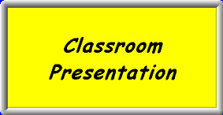, 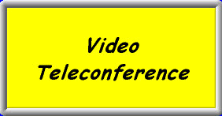, or 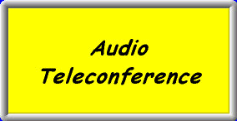depending upon the equipment you want to use.
- From Classroom Presentation: From this menu you can control your laptop, the DVD player, the VCR, cable TV, auxiliary computers or video equipment, or play a CD.
- From Video Teleconference: From this menu you can control the DVD player, the VCR, auxiliary computers or video equipment, and video teleconference equipment (cameras and telephone).
- From Audio Teleconference: From this menu you can control only telephone equipment.

- Control the equipment you want to use with the Touch Panel system, including the slide projectors, your laptop computer, the VCR, the DVD/CD player, the cable TV tuner, the audio cassette player, or auxiliary equipment. From the individual control screens you can also:
- Touch 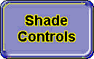 to lower or raise the room shades or the individual projection screens.
- Touch 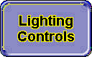 to change the room lighting.
- Touch  or  to increase or decrease the level of sound. Use  to mute sound totally. Touch  to reactivate sound.
- Touch 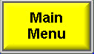 to return to the main menu to access the Shutdown procedure.
- When you are finished:
  - Touch , then touch 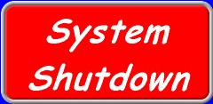 to end your session. The Shutdown Warning displays.
  - Touch  to end your session or touch  if you’ve started the shutdown process by mistake.
Note: You cannot turn the projection system back on for 3 minutes after shutdown.

Notes: It is important that everything is turned off to protect the integrity of the security system and extend the life of the electronic equipment.
You must remove your media from the equipment in the racks BEFORE you turn off the system power.

Screen And Shade Controls
Shades:
- On any screen, touch .
- Touch or in the Shades area.

Room Light Controls
- On any screen, touch to control the room lights. A pop-up window with the following buttons appears. It closes in five seconds if you don’t use it.
- Touch 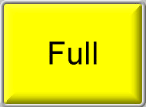, 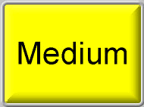, 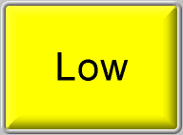, , or 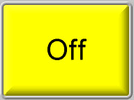 to achieve the desired lighting level.

Projection From Your Computer
It is critical to the success of projecting a computer image that you follow this procedure in the order outlined below.
- Connect your computer to the computer input cables on the presentation table.
Please note that your computer should be in full shutdown mode (not in Sleep mode) when you make cable connections.
- Projection of the computer image requires the 15-pin cable.
- Computer sound amplification requires the mini-stereo cable.
- Connect your computer to the network cable tethered to the computer interface cable.
- Follow steps 1-3 in the section Using The Touch Panel.
- Touch , and then touch 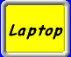 on the Touch Panel menu.
- Touch the 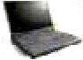 icon that represents your laptop’s position around the table.
- Start your computer (note that a Macintosh G3 must be started after the projection system).
- If the projection screen has an error message on it saying INPUT A NO INPUT, see the section What To Do If Your Computer Doesn’t Project.
- If your computer projects on the screen but you cannot access the network, see the section What To Do If Your Windows Computer Can’t Access The Network.
- Computer sound volume is increased or decreased by touching or on the Touch Panel. Use to mute sound totally. Touch to reactivate sound.
- When you are finished:
- Touch , then touch to end your session. The Shutdown Warning displays.
- Touch to end your session or touch if you’ve started the shutdown process by mistake.
Note: You cannot turn the projection system back on for 3 minutes after shutdown.

What To Do If Your Computer Doesn’t Project
You may have to manipulate your computer so it will send its display to the projection system:

On A Windows Computer
Press and hold 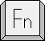 and press the function key that controls monitor selection to cycle between input options. The function key is 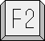, 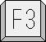, , 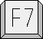, or 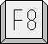 on most PCs — it will be marked with CRT/LCD or a monitor icon (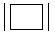 or ). The input options are:
- Video output going to the computer monitor only.
- Video output going to the computer monitor and to the projection screen.
- Video output going to the projection screen only.

On A Macintosh Computer Using OS 8 or 9
If you started your computer before you connected to the projection system, you should restart your computer first to see if that fixes the problem. If this doesn’t fix the problem, keep in mind that on a Macintosh computer, there are two methods to redirect video output. The method you use will depend upon what you see in the Monitors or Monitors and Sounds control panel. Both methods will require you to use the Control Strip, which looks like a belt with a buckle on it, to access the appropriate control panel.
Method 1
- Use the Control Strip, it looks like a belt with a buckle. If only the ‘buckle’ is visible on your screen, click  to extend the Control Strip.
- Click  and select Open Monitors Control Panel or Open Monitors and Sounds control panel from the pop-up menu.
- In the Resolution field, you will see a variety of resolution options. Click to select one of the options that are followed by the word Simulscan.
Note: There may be several options including 640 x 480, 800 x 600, and 1024 x 768. Do not select anything larger than 1024 x 768, the larger the number, the smaller the image projected. Anything above 1024 x 768 will not be easily readable.
- Close the control panel.

Method 2
- Use the Control Strip, it looks like belt with a buckle. If only the ‘buckle’ is visible on your screen, click to extend the Control Strip.
- Click and select Open Monitors Control Panel or Open Monitors and Sounds control panel from the pop-up menu.
- You will see four buttons along the top of the control panel. Click the button labeled Range; the window will change.
- You will see two monitor icons; one will be small, the other large. If you look at the projection of the display, you will see the background color of the laptop monitor but none of the icons. Click and drag the small monitor icon so it is on top of the large monitor icon. You should see the screen image with icons on the monitor and the projection screen.
- Close the control panel.

On A Macintosh Computer Using OS X
If you started your computer before you connected to the projection system, you should restart your computer first to see if that fixes the problem.
- Click 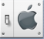 on the Dock. The System Preferences window opens.
- Click 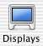. The Color LCD window displays.
- In the Resolution field, you will see a variety of resolution options. Click to select one of the options.
Note: There may be several options including 640 x 480, 800 x 600, and 1024 x 768. Do not select anything larger than 1024 x 768, the larger the number, the smaller the image projected. Anything above 1024 x 768 will not be easily readable.
- Click the close button to close the Color LCD window.

What To Do If The Projected Image Does Not Look As It Should
If the screen still has no image, or the image is off-center or the color of the desktop image is not what is expected, touch 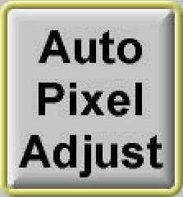.

What To Do If Your Macintosh OS 9 Computer Can’t Access The Network
- On the menu, point to Control Panels; then select TCP/IP from the submenu. The TCP/IP control panel opens.
- On the Connect Via drop-down list, select Ethernet.
- On the Configure drop-down list, select Using DHCP Server.
- On the menu, point to Control Panels; then select AppleTalk from the submenu. The AppleTalk control panel opens.
- On the Connect Via drop down list, select Ethernet.
- Close both control panels; then click  on the dialog box that pops up.

What To Do If Your Macintosh OS X Computer Can’t Access The Network
  - Click on the Dock. The System Preferences window opens.
  - Click . The Network control panel opens.
  - From the Show drop-down list, select Built-in Ethernet.
  - Click .
  - Close the System Preferences window.

What To Do If Your Windows Computer Can’t Access The Network
TCP/IP based services (such as web access), require your laptop to have an IP address which it gets by querying Middlebury’s DHCP server during startup. The server gives the querying computer a set of configuration parameters valid for the location of the computer called a lease, which it can use for a set period of time. When the lease expires, the Windows computer requests a new lease.
When you move a laptop with a valid lease from one sub-network to another it will not request new data from the server and the data may be invalid for your new location. For instance, in Bicentennial Hall, each floor is in a different subnet and computers must have different configuration parameters. So you should perform the following procedure whenever you move your computer from one location to another even if you think you have not changed sub-networks.
- Click and select Run from the pop-up menu; the Run dialog box will open.
- In the Open text box, type command.
- Click . The command.com window opens.
- Release and renew IP information for all adaptors.
- On a Windows NT, Windows 2000, or Windows XP computer:
  - At the prompt, type ipconfig /release and press 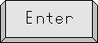.
  - At the prompt, type ipconfig /renew and press .
  - At the prompt, type exit and press . The command.com window closes.
- On a Window 95, Windows 98, or Windows ME computer:
  - At the prompt, type ipconfig /release_all and press .
  - At the prompt, type ipconfig /renew_all and press .
  - At the prompt, type exit and press . The command.com window closes.

Projection From The DVD Player
- Follow steps 1-3 in the section Using The Touch Panel.
- Touch or .
- Touch 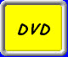 on the menu. The DVD Controls menu displays.
- Press  (Open/Close) on the DVD player and load the media into the player.
- Press (Open/Close) on the DVD player again to close it.
- Several buttons on the DVD Controls menu help you control the viewing of your video.
-  reverses the DVD by one chapter; each touch of the button reverses play by one chapter.
-  touch to play in reverse.
-  begins play.
-  pauses the DVD leaving the image on the screen.
- One touch of  stops the DVD and projects a medium blue blank image on the screen. The DVD will restart from the point where you stopped. To cancel the resume feature, touch again.
-  touch to fast forward.
-  fast-forwards the video by chapter; each touch forwards by one chapter.
  - Sound volume is increased or decreased by touching or on the Touch Panel. Use to mute sound totally. Touch to reactivate sound.

  - To activate the DVD menu, touch . The menu on the disc will display on the projection screen.
- Touch the arrow buttons to move around the menu (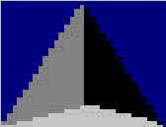, 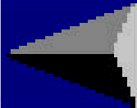, 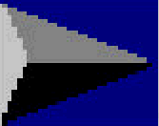, 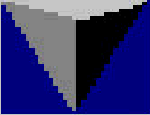).
- Touch  to select a highlighted feature.
- Remove the DVD by pressing (Open/Close) on the DVD player.
- When you are finished:
  - Touch , then touch to end your session. The Shutdown Warning displays.
  - Touch to end your session or touch if you’ve started the shutdown process by mistake.
Note: You cannot turn the projection system back on for 3 minutes after shutdown.

Projection From The VCR
- Follow steps 1-3 in the section Using The Touch Panel.
- Touch or .
- Touch 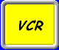 on the menu. The VCR Controls menu displays.
- Load the video into the VCR; it begins to play automatically, if the cassette’s tab is broken.
- Several buttons on the menu help you control the viewing of your movie.
-  reverses the video.
- If you want a medium blue blank image projected onto the screen during reverse play, touch , then .
- If you want to scan the video in fast reverse and have it display on the screen, touch while the video is in Play mode.
- begins video play.
- pauses the video leaving the image on the screen.
- stops the video and projects a medium blue blank image on the screen.
-  performs a fast-forward scan of the video.
- If you want a medium blue blank image projected onto the screen during forward scan, touch , then (you can monitor progress with the time indicator on the VCR).
- If you want to scan the video in fast forward and have it display on the screen, touch while the video is in Play mode.

- Sound volume is increased or decreased by touching or on the Touch Panel. Use to mute sound totally. Touch to reactivate sound.
- Remove the video by pressing (Eject) on the VCR.
- When you are finished:
  - Touch , then touch to end your session. The Shutdown Warning displays.
  - Touch to end your session or touch if you’ve started the shutdown process by mistake.
Note: You cannot turn the projection system back on for 3 minutes after shutdown.

Projection From Cable TV
This feature is not yet activated. Thank you for your patience.

Playing A CD
- Follow steps 1-3 in the section Using The Touch Panel.
- Touch , and then touch on the menu. The DVD Controls menu displays.
- Press (Open/Close) on the DVD player and load the CD into the player.
- Press (Open/Close) on the DVD player again to close it.
- Several buttons on the DVD Controls menu help you control the play of the CD.
-  begins play at the beginning of the previous track.
- allows you to reverse scan so you can replay a passage.
- begins play.
- pauses the CD.
- stops the DVD player. The CD will restart from the point where you stopped. To cancel the resume feature, touch again.
- allows you to skip portions of the CD.
-  begins play at the beginning of the next track.
- Sound volume is increased or decreased by touching or on the Touch Panel. Use to mute sound totally. Touch to reactivate sound.
- Remove the CD by pressing (Open/Close) on the DVD player.
- When you are finished:
  - Touch , then touch to end your session. The Shutdown Warning displays.
- Touch to end your session or touch if you’ve started the shutdown process by mistake.
Note: You cannot turn the projection system back on for 3 minutes after shutdown.

Projection From Auxiliary Equipment
A special set of input receptacles is located in the equipment rack. Use them to connect other audio/visual sources such as U-Matic, Beta or multi-standard type VCRs such as PAL or SECAM compatibles. The projectors are compatible with all current video standards.
- Connect your equipment using special audio and video interconnection cables (contact Media Services) to a special set of receptacles located in the equipment rack.
- Refer to the device manual for set-up and operating instructions.
- Follow steps 1-3 in the section Using The Touch Panel.
- Touch or .
- Touch the button appropriate for the type of auxiliary equipment you are using:
- Touch 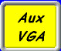 to use an auxiliary computer. The Aux VGA screen displays. If the projection screen has no image, or the image is off-center or the color of the desktop image is not what is expected, touch 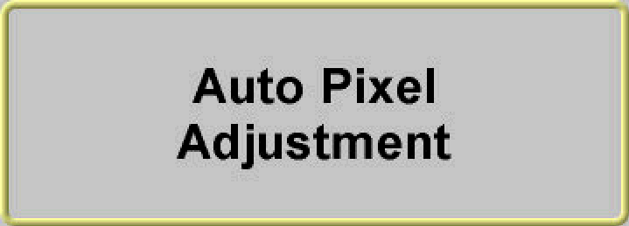.
  - Touch  to use an auxiliary video source. The Aux Vid Input screen displays; there are no options available. Control the equipment using physical buttons.
- Sound volume is increased or decreased by touching or on the Touch Panel. Use to mute sound totally. Touch to reactivate sound.
    - When you are finished, finished:
  - Touch , then touch to end your session. The Shutdown Warning displays.
  - Touch to end your session or touch if you’ve started the shutdown process by mistake.
Note: You cannot turn the projection system back on for 3 minutes after shutdown.

Audio and Video Teleconferencing
Library 230 has built-in video and audio teleconferencing services. You must contact Media Services at x2200 for assistance with setup and testing of video and audio teleconferencing links. Please call at least one week in advance to allow time to complete testing.

Trouble Shooting
If there is no picture: | - Reselect the input device on the Touch Panel system.  - If you are using a laptop, see the sub-sections of Projection From Your Computer concerning directing output.
If there is no sound: | - Reselect the input device on the Touch Panel system.  - Adjust the volume on the device you are using by touching several times.  - Touch to turn off the mute feature.

Getting Help
Call the Helpdesk at x2200 for assistance with software, A/V equipment, and network problems.

